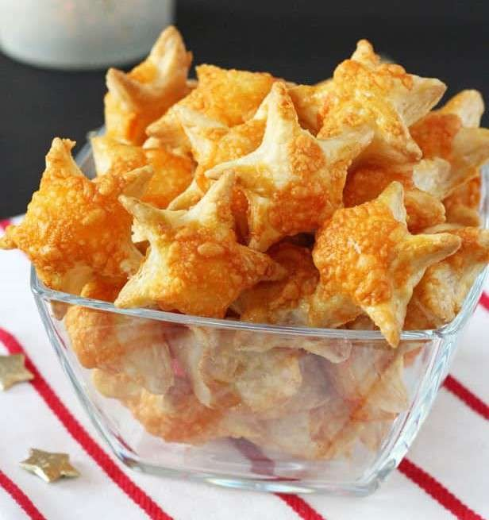

Prep Time: 10 minutes.

Cook Time: 10 minutes.

Ingredients

* 375g ready rolled puff pastry sheet
* 1 egg
* 50g grated cheddar cheese
* A little plain flour

Instructions

1. Preheat the oven to 180c and line a baking sheet with greaseproof paper.
2. Roll out the puff pastry sheet onto a floured surface. Use a star shaped cookie cutter to cut out individual pastry pieces and place them on the baking sheet. Using the egg, apply a thin layer of egg wash to the top of each pasty star and then top with a little cheese.
3. Bake in the oven for 10-12 minutes until the stars are golden.
4. Serve immediately or keep in an airtight container for up to 2 days.