Cinnamon Stick Stars

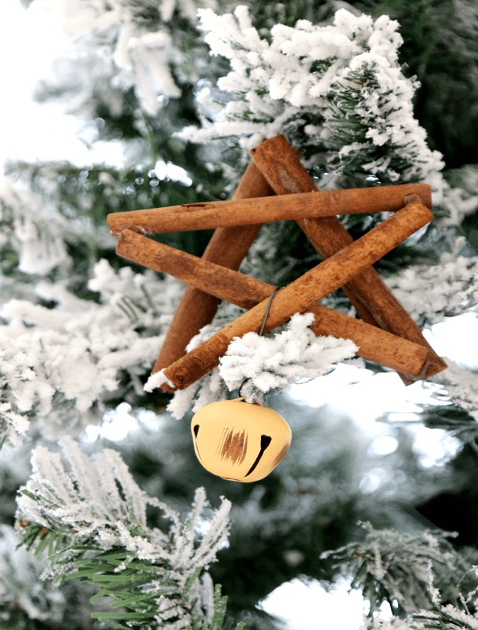

* Cinnamon Sticks
* Bell or glitter glue
* Tiny wire
* Glue stick
* String/ ribbon

This decoration is easy to make and also has a great smell. First lay out the cinnamon sticks into a star shape. Then glue them in place.

Decorate with glitter glue or attach a tiny bell or tinsel. Tie a piece of string or ribbon on top so that you can hang it up in your room or on the Christmas tree.