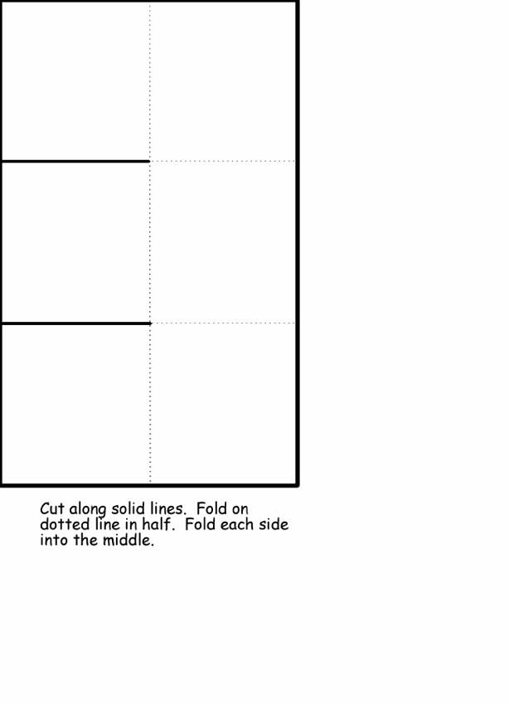
www.HomeschoolHelperOnline.com

